**EXPERIMENT 5**

**EXTRA QUESTION:**

Q1

print("20438 UMME ATIYA")

n=0

while(n<5):

print(n)

n=n+1

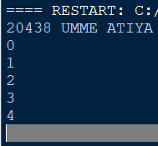

Q2 sq of n num using while loop

print("20438 UMME ATIYA")

n=int(input("Enter a number:"))

i=1

while(i<=n):

print(i,":",i*i)

i=i+1

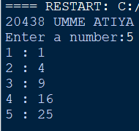

Q3

print("20438 UMME ATIYA")

for l in 'pyhton':

print(l)

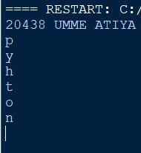

Q4

print("20438 UMME ATIYA")

l=5

for l in range(5):

print(l)

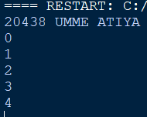

**EXERCISE:**

Q1

print("20438 UMME ATIYA")

n=10

s=0

for i in range(1,n+1):

s=s+i

print("Sum of digits till 10:",s) 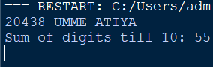

Q2

print("20438 UMME ATIYA")

n=0

while(n<=100):

print(n,end=' ')

n=n+2

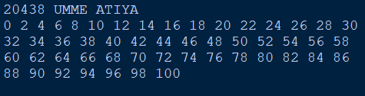

Q3

print("20438 UMME ATIYA")

n=int(input("Enter a number:"))

a=0

b=1

s=0

print(a)

print(b)

while(s<=n):

s=a+b

print(s)

a=b

b=s

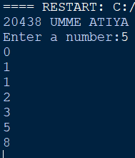

Q4

import math

print("20438 UMME ATIYA")

n=int(input("Enter a number:"))

print("Factorial ", math.factorial(n))

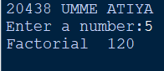

Q5

print("20438 UMME ATIYA")

n=int(input("Enter a number:"))

fact=1

if n>=1:

for i in range(1,n+1):

fact=fact*i

print(fact)

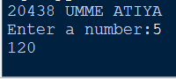

Q6

print("20438 UMME ATIYA")

n=int(input("Enter a number:"))

r=0

rev=0

while n!=0:

r=n%10

rev=rev*10+r

n=int(n/10)

print(rev)

